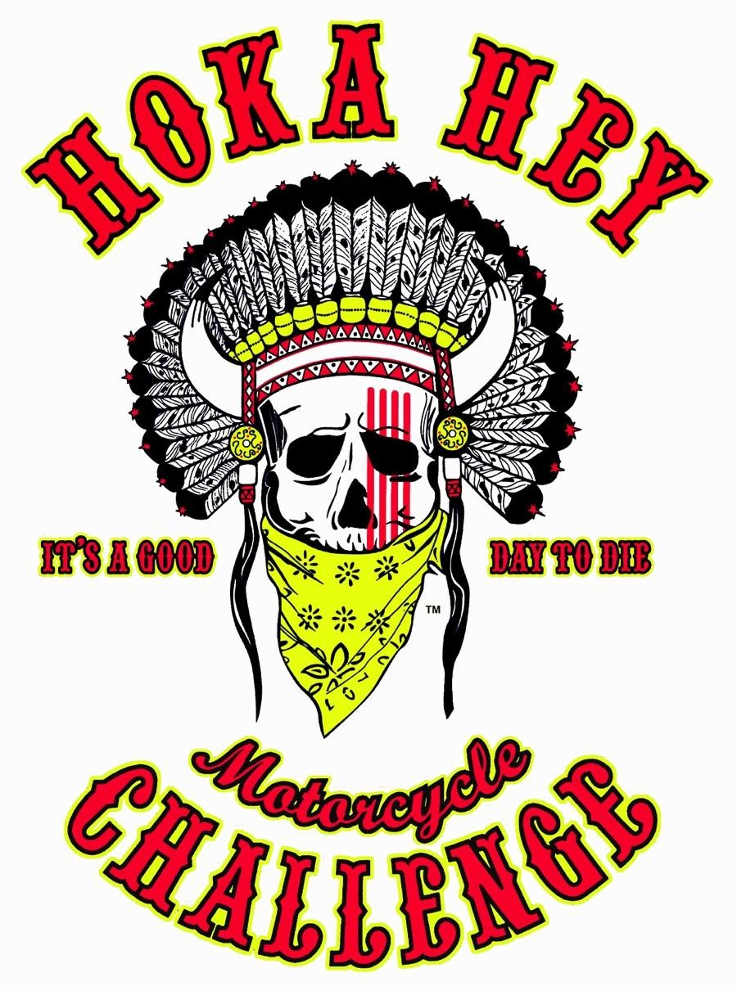
The Hoka Hey Motorcycle ChallengeTM is a grueling battle of endurance and determination that will change riders’ perspectives by making them dig deep within to find whether they have strength of mind or sense of purpose.

HOKA HEY MOTORCYCLE CHALLENGE
TM

RIDER PACKAGE

This document presents information about the Mission, Objectives and Strategies for this epic event.

THE MISSION OF THE HOKA HEY MOTORCYCLE CHALLENGETM:
Organized by the Medicine Show LLC and billed as the “World’s Greatest Endurance Challenge”; the Hoka Hey Motorcycle ChallengeTM (HHMC) is a grueling and unforgiving endurance ride which provides participants with an opportunity to test their fortitude and determination. By facing and overcoming obstacles along the way, participants are encouraged to journey into a deep and critical examination of their own motives, actions and beliefs and then to translate newfound strength and confidence into a willingness to act on behalf of others. Through the HHMC, the Medicine Show LLC endeavors to:
- Enrich – to cultivate a philosophy of respect, honor, integrity and compassion
- Empower – to promote self- determination and strength
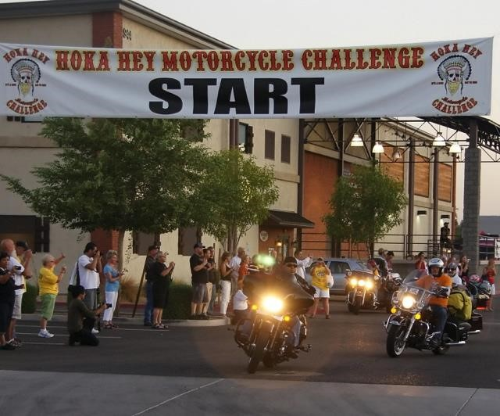
- Unite – to join together to incite positive action.

OUR MESSAGE:
Much more than a soldier who protects and defends the people; a warrior is a teacher, a mentor, a guide and a provider who lends strength to the people and is attentive to their needs. The stronger the warrior is – the stronger the people are. The warrior spirit will always surface for those who run this demanding challenge with honor, tenacity and heart.

WHAT IS THE HOKA HEY MOTORCYCLE CHALLENGETM?
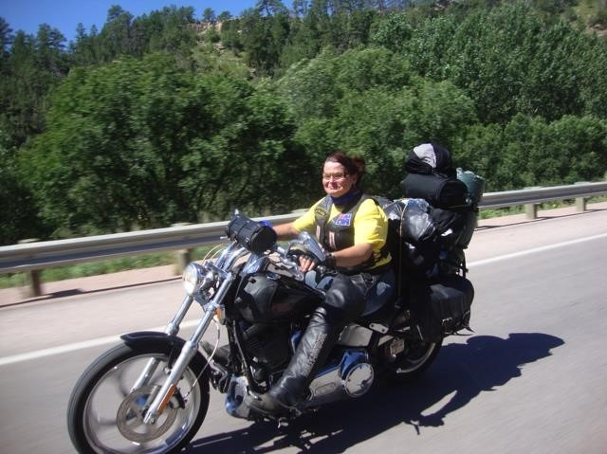
The HHMC is a long distance motorcycle endurance ride in which participants must navigate some of North America’s least traveled roads while adhering to an extremely high standard intended to test their mettle and integrity.
- This is an arduous event that demands each rider have the courage and conviction to overcome the harshest of conditions.
- Averaging 9,800 miles long; our routes follow a different course each time, taking riders to new places throughout North America.
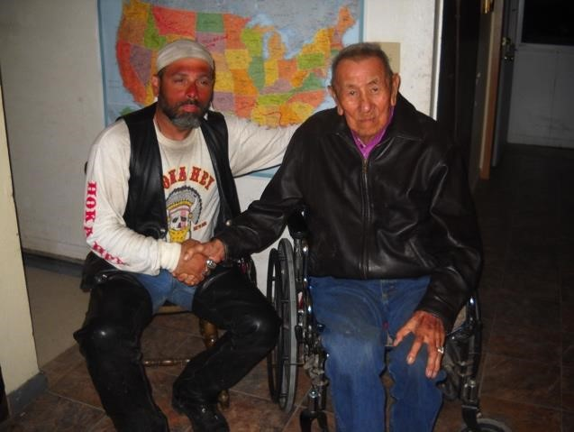
- By offering vast amounts of technical riding primarily on two lane roads through scenic mountain passes and Native American reservations this event entices “Searchers” from around the globe. Our riders span a wide demographic ranging in ages from 21 to 80.
- Checkpoints are strategically placed at dedicated Harley Davidson dealerships and supporting businesses all across the continent.
- World class parties with food, fireworks, music and prizes.
Embodying the spirit of the traditional vision quest (a deep, inward search for transformation and insight), the trying circumstances force riders to discover their own boundaries of personal strength and to redefine the way they see the world.
By sending Challengers through some of the most beautiful areas in the country, this heart-pounding adventure keeps people coming back for more! The Hoka Hey Motorcycle ChallengeTM creates a unique experience that your supporters, sponsors and donors will find informative and entertaining while encouraging awareness of social issues in America and providing opportunities to get involved.
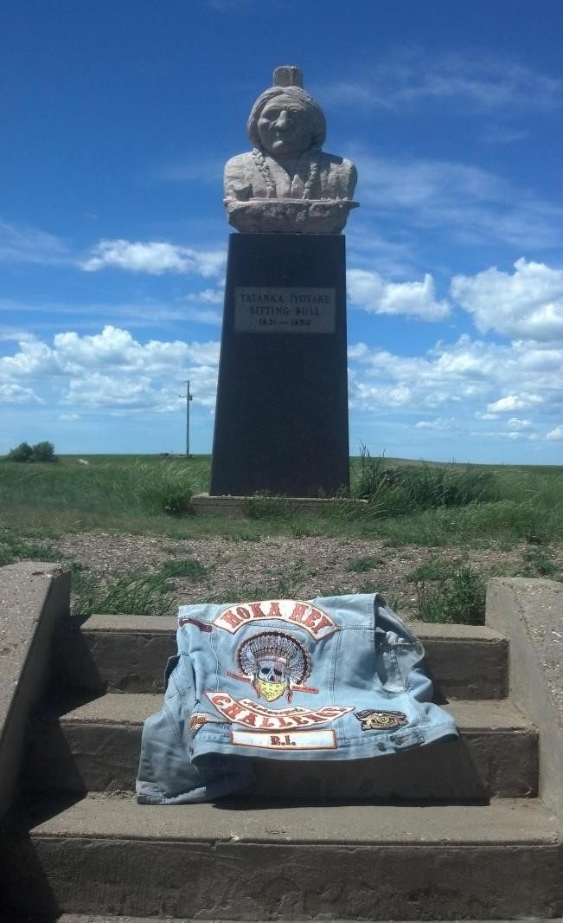
OUR OBJECTIVES:
The primary objectives of the Medicine Show LLC are:
- To use the Hoka Hey Motorcycle ChallengeTM to create awareness for social issues by sending Challengers through some of the most poverty-stricken places in North America.
- To inspire a desire and willingness to accept personal accountability with a sense of duty and principle; to cultivate wisdom, community and compassion and to display and foster respect, harmony, peace and friendship.
- To create an army of warriors with the strength to face adversity; the character to make sacrifices and the desire to come to the aid of others in need.
- To empower others who struggle with physical, mental or financial challenges and to show them they do not face these obstacles alone. By our actions, we become a driving force that helps them move forward with a focus on success.

YOU ARE INVITED TO BE PART OF THE EXPERIENCE!
Individuals participating in the Hoka Hey Motorcycle ChallengeTM are encouraged to conduct fund raising efforts on behalf of a charity organization or individual. One of the characteristics the HHMC is looking for in our riders is the desire to help others.

Although fund raising is not mandatory* it is encouraged.

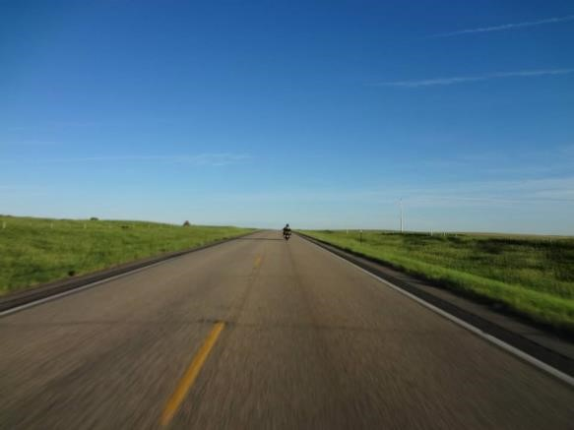
Participants and their supporters can accomplish this thru a

variety of ways:

- Take pledges for miles ridden during the Challenge.
- Host a spaghetti supper or pancake breakfast.
- Team with local business & hold a “Hoka Hey Party” with proceeds from sales going to the cause.
- Get a sponsor to provide an item or hold a 50/50 raffle.
- Go to http://www.fundraiserinsight.org/ideas/ for 140+ more brilliant fund raising ideas!!
With twenty-two million people out of work in America and 33% of the homeless population being families with children– the time to act is now.
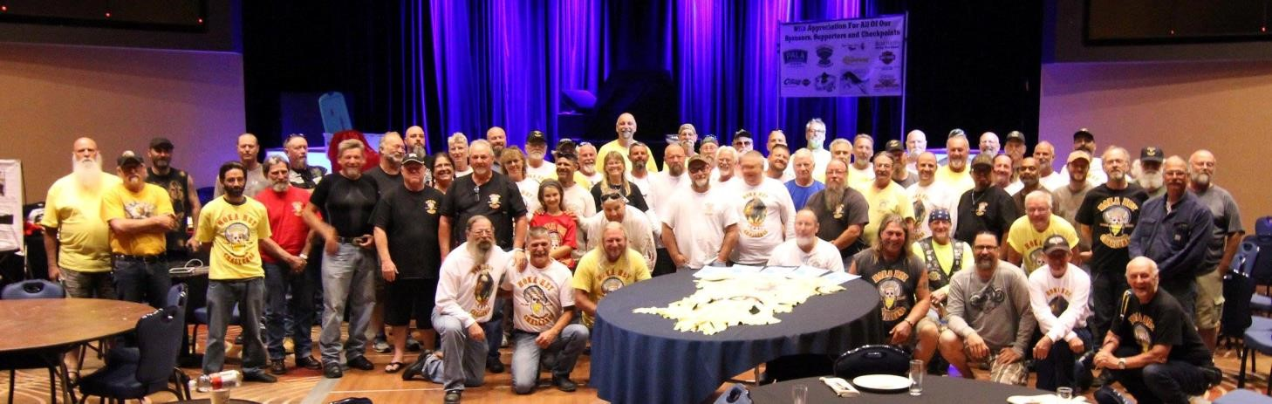

To learn more about the Hoka Hey Motorcycle Challenge, please visit our website www.hokaheychallenge.com. To learn more about collaboration or fund raising opportunities please contact:

Beth Durham
Director of Operation, Hoka Hey Motorcycle Challenge
P.O. Box 710
Hot Springs, SD 57747 Phone: 605-890-0386

beth.durham@hokaheychallenge.com

To learn more about fund raising opportunities please contact:

Junie Rose
Director of Rider Relations
217-343-4424

junie.rose@hokaheychallenge.com

* Fund raising is voluntary, not a requirement to participate in the Hoka Hey Motorcycle ChallengeTM. Riders are solely responsible for the fund raising efforts. The Medicine Show LLC will assist riders to help make their efforts successful, but the Organization is not obligated or responsible to the charity.

